TEAM PROJECT GENERAL DESIGN

Team 5 Project - Rental Property Management Company

CIS 4800 DMWA

10/22/24

Mashya Mumin - mashya.mumin59@baruchmail.cuny.edu
Franco Rosito - franco.rosito@baruchmail.cuny.edu
Andrew Santos - andrew.santos@baruchmail.cuny.edu
Tahmid Shafin - tahmid.shafin@baruchmail.cuny.edu
John Sy - johnpatrick.sy@baruchmail.cuny.edu

Table of Contents

Title Page: Page 1
Table of Contents: Page 2
General Design (Appendix A): Page 3-11
Executive Summary (Page 3)
Project Introduction (Page 3)
Project Identification (Page 3-4)
System Request (Page 4-5)
Stakeholders (Page 5)
Feasibility Analysis (Page 5-6)
Requirements (Page 6-7)
System Analysis Modeling (Page 7-8)
Testing (Page 9)
System Elements for Civic/Ethical Decision-Making/Legal Factors (Page 9)
System Elements for International (Global) Factors (Page 9)
Technological Approach (Page 9-10)
Assumptions (Page 10)
Constraints (Page 11)
Glossary (Appendix B): Page 12
Participation Report (Appendix C): Page 13-14
Project/Product/Presentation Peer Review (Appendix D): Page 15-16
Reference/Integrity/Signatures (Appendix E): Page 17
Grading Rubric (Appendix F): Page 18-19

APPENDIX A

GENERAL DESIGN

Executive Summary (Andrew)
Summarize the content of the deliverable including the name of the organization and highlights of the project.
The Rental Property Management Company is undertaking a project to develop a comprehensive Building Maintenance System . This system aims to streamline the management of maintenance requests from tenants across multiple rental buildings that are managed by the company. The primary objective is to replace the current manual process with a more efficient system that provides real-time updates. Key features of the system include account creation for tenants, submission and tracking of maintenance requests, priority categorization of issues, and real-time updates. The implementation of this system is expected to improve operational efficiency, reduce miscommunication, and enhance tenant satisfaction.

Project Introduction (Andrew)
Briefly describe the organization that needs the project, including location, type and size of the business, type and number of employees.

The Rental Property Management Company, located in the city, oversees several residential buildings. As a property management business, it employs maintenance managers and maintenance crew members to ensure the upkeep of these properties. The company is currently facing challenges in managing maintenance requests efficiently due to a manual process that lacks real-time updates and effective communication. This project aims to address these issues by developing a comprehensive Building Maintenance System that will facilitate better coordination and faster resolution of maintenance requests.

Project Identification (Mashya)
- Prepare one or two paragraphs for each of the following:
  - Problem Statement: Describe the problem or opportunity that the project will address
  - Solution Statement: The proposed solution to the problem
- List two or more alternatives to the proposed solution.

Problem Statement:
The rental property management company is currently facing challenges with managing maintenance requests from tenants across multiple buildings in the city. Tenants are getting frustrated as they are experiencing delays getting their maintenance issues resolved because there is no system to streamline the processing of these requests. Maintenance managers, who oversee multiple buildings, are overwhelmed with requests from tenants and struggle to efficiently assign tasks, track progress, and ensure that urgent issues are addressed in a timely manner. The lack of a system leads to tenant dissatisfaction and inefficient use of the maintenance crew's time and resources.
Solution Statement:
The proposed solution is to develop a building maintenance system which provides a platform for tenants, maintenance managers, and maintenance crew members to submit, assign, track, and manage maintenance requests in real time. Tenants will be able to log into the system to submit maintenance requests for their apartments. Each maintenance request will have a request ID, category, and description. Maintenance managers will have the ability to categorize requests based on low, medium, and high priority: low-priority issues are to be resolved within seven days, medium-priority issues within 3-5 days, and high-priority issues within 24 hours. Maintenance crew members will be able to log in, view assigned tasks, what the task priority level is, and update the status of these tasks once they are completed.
By implementing this system, the company can improve communication between tenants, managers, and maintenance staff to ensure that tasks are completed based on priority. This system would help streamline operations, improve accountability, and reduce delays in maintenance resolutions.
Alternative Solutions:
- Using a pre-existing maintenance management system
- Outsource the maintenance management process to a third-party service provider.

System Request (Franco)
Create a System Request. Provide the name of the project sponsor. The system request should include a description of the business need, business requirements, the expected business value the system should provide, and any special issues, constraints, or risks to the business.
Project Sponsor : Property Management Company
Business Need : property management company, is facing significant challenges in managing maintenance requests efficiently across multiple buildings. The current manual process lacks real-time updates and communication between tenants, maintenance managers, and the maintenance crew. This leads to delays, miscommunication, and decreased tenant satisfaction.
Business Requirements :
Account Creation : the system should allow maintenance managers to create tenant accounts for each person in their buildings
Maintenance Request : Each tenant should be allowed to submit a maintenance request that includes category, description and how high of a priority it is
Maintenance Priority Confirmation: each manager should categorize each issue based on priority low, medium or high and confirm, which will help the crew resolve the issues based on how quickly they need to be fixed
Task Assignment and Updates : Maintenance managers should be able to assign tasks to maintenance crew members and monitor the progress. Crew members should be able to log their status updates (in-progress, closed).
Scalability : the system should be able to accommodate a large and increasing number of tenants across multiple buildings
Expected Business Value:
Efficiency : improved communications throughout all stakeholders which will reduce delays and improve maintenance issues.
Transparency : the system will provide real-time updates
Tenant Satisfaction : will improve the satisfaction of tenants within each building because of the communication and efficiency of the maintenance system
Special Issues/Risks:
Data Security & Privacy: Ensuring robust protection of tenant information through encryption, secure authentication, and compliance with privacy regulations like GDPR and CCPA.
Integration: Overcoming technical challenges with existing systems, ensuring smooth data migration, and minimizing disruption during the transition.
Adoption: Providing comprehensive training and support to ensure tenants and managers can easily adopt and effectively use the new system.

Stakeholders (John)
Provide a list of three or more key stakeholders. Add their title, role, and impact on the project. Do not include the project team members.
- Rental Property Management Company (Owner): they will be the ones who will own/operate the system to manage the buildings/properties.
- Tenants (Primary Actors): they are the ones who will be directly affected the most. With this new system, tenants from each of the buildings are able to submit maintenance requests within the system without having to deal with contacting their landlord, or maintenance manager.
- Maintenance Managers: they’re responsible for creating accounts in the system for each tenant in their building, and also categorize/measure which issues are considered to be “higher” priority (from low, medium, to high).
- Maintenance Crew Members: these people follow directions from their maintenance manager, they make sure to login the system and check up on any issues that tenants may have. Once it is resolved, they log back into the system and change it to “Resolved”.

Feasibility Analysis (John)
- Evaluate the technical, economic, and organizational feasibility of doing the project, showing how the benefits of implementing the system outweigh the risks of not doing the project.
- Determine one or more (if any) relevant Civic, Ethical, Legal, International (Global) related factors that might impact the feasibility of the project.

For technical feasibility, this project would require the necessary technologies such as a database management, cloud infrastructure platform which could be used with Google Cloud Platform, AWS, etc. With a platform like Google Cloud Platform, it’ll be easier to scale up to handle large amounts of data and support a wide range of users across all of the buildings/properties, whether it’s the tenants or the maintenance manager. One risk would be the difficulty of integrating the system with the existing technology at hand, or if everyone’s devices are compatible.

For economic feasibility, the benefit of doing this project would ultimately save time and hassle for all sides. It would make it easier for the tenants so they don’t have to worry about reaching out to their landlord when they have a maintenance crew in their building to check up on any issues (heating/cooling, leaks, etc.). One risk that could popup could be the strenuous time and cost to develop and maintain this project/system.

For organizational feasibility, in order for this project to succeed, it needs to be regularly maintained by the management and everyone has access to the system and needs to be shown an overview of the system so that each stakeholder has at least an understanding of how the system functions. One risk that could occur could be how slow it is to implement the system, as not everyone can grasp how to use the technology that’s used within the project.

One ethical related factor would be to make sure that the data of each of the tenants are protected and encrypted.

Requirements (Mashya)
List SMART requirements for the proposed solution:
- List of all Users and how they will use the new system
- List 10 or more Functional Requirements that satisfy the System Request business requirements
- List five or more relevant Non-functional Requirements

SMART Requirements
- Specific: Tenants should be able to submit maintenance requests that include a category and description
- Measurable: Maintenance requests must have a request ID, and their status (open, in-progress, closed) must be viewable by tenants, maintenance managers, and maintenance crew members
- Achievable: Maintenance managers must be able to categorize requests based on low, medium, or high priority, which sets deadlines (7 days, 3-5 days, or 24 hours) for the maintenance crew
- Relevant: The system should allow the maintenance crew to see tasks prioritization level and enable them to update the status of the maintenance requests
- Time-bound: 6-8 months to create system

List of all Users and how they will use the new system
Tenants:
Submit maintenance requests specifying category, description
View the status of submitted requests (open, in-progress, closed)
Maintenance Manager:
Create accounts for tenants
View maintenance requests for their building and categorize them based on priority (low, medium, high)
Delegate maintenance tasks to crew members
Monitor the status of requests and ensure tasks are being done according to their priority level timeframes
Maintenance Crew:
Log in to check assigned maintenance tasks
View tasks based on prioritization and urgency (low, medium, high)
Update the status of tasks from open to in-progress and then to closed

List 10 or more Functional Requirements that satisfy the System Request business requirements

- Tenant Registration: The system must allow maintenance managers to create tenant accounts
- Request Submission: Tenants should be able to submit maintenance requests including the category of the issue and provide a description
- Request ID: Each maintenance request must have a unique request ID automatically generated by the system
- Request Status Tracking: The system should enable tenants, managers, and maintenance crew to track the status of requests (open, in-progress, closed)
- Request Progress Updates: Maintenance crew members should be able to update the status of their progress by changing the status from in-progress to closed
- Request prioritization: Maintenance managers must be able to categorize each maintenance request as low, medium, or high priority
- Task Assignment: Maintenance managers should be able to delegate specific maintenance requests to individual crew members
- Priority-based Sorting: The system should automatically sort maintenance tasks for the crew based on the urgency, the high priority tasks should be at the top of the list
- Deadline Management: The system should set task deadlines based on their allotted priority level
- Notification System: The system should automatically send out notifications (to maintenance manager/crew members) when the status of a request changes

List five or more relevant Non-functional Requirements

- Password: Users must be able to reset their password
- Scalability: The system must be able to scale to handle the possible increase in the number of tenants
- Security: The system must make sure that users only have access to the data and features relevant to their role
- Usability: The system’s interface should be user-friendly and easy to use
- Mobile-friendly: The system should be mobile-friendly so maintenance managers and crew can update tasks flexibly

System Analysis Modeling (EVERYONE)
High-Level models of the functional requirements and future system:
- Create a system Use Case Diagram of the proposed system
- For each Actor prepare a use case specification for one or more of the use cases they perform
- Business Process Model: Activity diagram showing the entire business process flow
- Identify the analysis classes for the new system

Activity Diagram
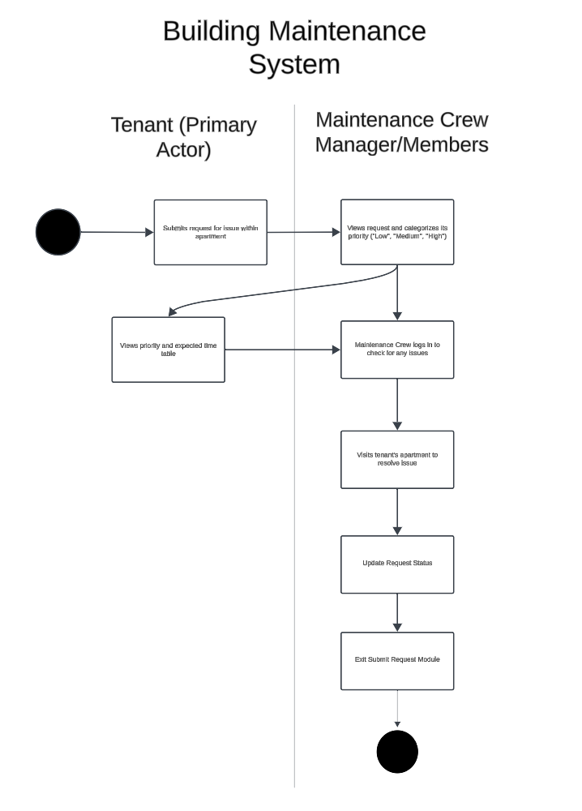

Use-Case Diagram (Mashya)
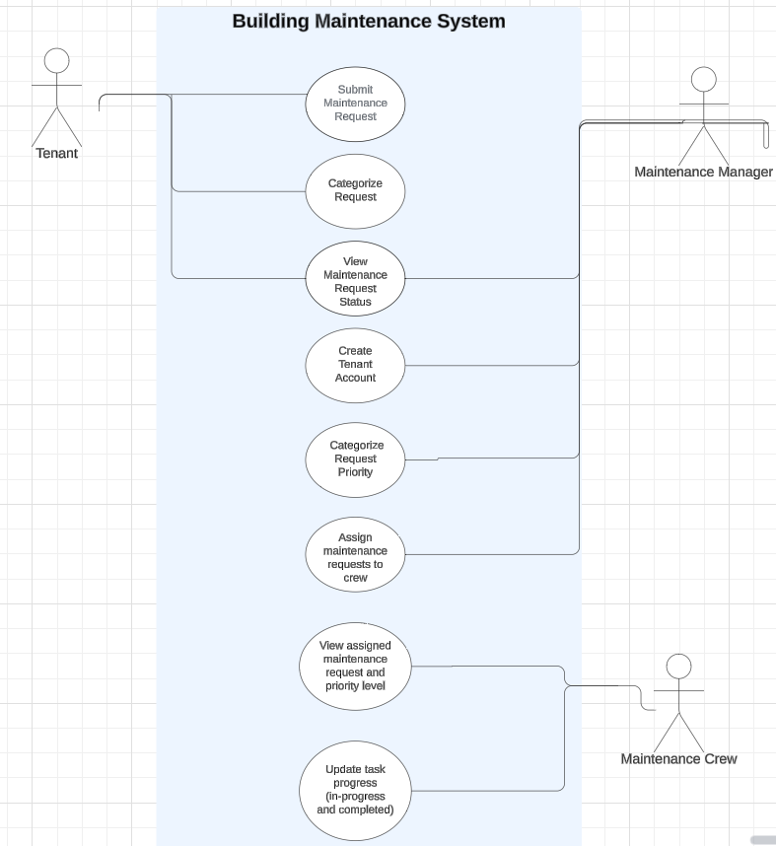

Testing
Create Test Scenarios to verify and validate the analysis
User Registration
Tests the functionality of creating a new tenant account by a maintenance manager.
Login Functionality
Validates that tenants can successfully log into the system with their credentials.
Request Submission
Checks whether tenants can submit maintenance requests, including category and description.
Request Status Tracking
Ensures that tenants can view the status of their submitted maintenance requests.
Priority Assignment
Verifies that maintenance managers can categorize maintenance requests by priority.
Task Assignment
Tests the ability of maintenance managers to assign maintenance requests to specific crew members.
Notifications/Updates
Tests if tenants receive notifications if priority is change or status updates on maintenance
Scalability
Tests to see if multiple tenants can use system at same time

System Elements for Civic/Ethical Decision-Making/Legal Factors (Mashya)
List one or more (if any), requirements, business rules, policy, or procedure needed to address the Civic, Ethical, Legal or any other responsible factor needed for the system.
The system must comply with data protection law. The tenants personal information including personal data regarding their contact details and apartment information must be securely stored, encrypted, and protected.

System Elements for International (Global) Factors (Franco)
List one or more (if any), requirements, business rules, policies or procedures needed to address the International (Global) factors needed for the system.
Multiple Language Support : Must be able to support different languages , based on the area of the world on which it operates ; Spanish . German, Japanese, etc
Policy/Regulation: ensure the system is compliant with local laws and ensure privacy is not invaded and all interactions within the system is legally compliant
Data Privacy and Protection : ensure that data is being kept safe and secure , providing users with the ability to access their data

Technological Approach: Tahmid
Describe all technology, tools, and/or techniques used for the analysis of the solution.
Google Cloud Platform(GCP): GCP will be used to host the system, providing a scalable and reliable infrastructure. GCP allows the system to handle increasing loads as the number of tenants and maintenance request grows
Cloud SQL: Cloud SQL will serve as the relational database, managing structured data such as tenant information, maintenance requests, and task statuses.
Python(Django): Develop the backend of the system using python using a web framework which is Django.

Assumptions: Tahmid
Indicate all assumptions used for the analysis of the system.
Increased Efficiency:
The building maintenance system will lead to increased efficiency for the property management. By centralizing maintenance requests and having a priority system, maintenance crew members will be able to organize and address requests/issues in a quicker and efficient manner.
User Adoption and Engagement:
Tenants, building managers, and maintenance crew members will actually adopt and consistently use this specific system for submitting, managing, and addressing maintenance requests
User Access to Request Details:
Users/tenants will have the ability to view the details of any requests made within the building maintenance system. This contains details such as priority level(low, medium, high) as well as the current status(open, in progress, closed), as well as any other updates and comments by the maintenance crew.
Adequate Technologies/Internet Access:
All users have access to adequate technologies and internet access so they can log in to the building maintenance system and use the features without issues.
Data Privacy & Security:
The building maintenance system will ensure that tenant data is secure and protected. This includes the encryption of sensitive data and ensuring that only the authorized personnel will have access to tenant records and details.
Technological Stability:
The cloud platform will provide a stable and scalable platform that allows the handling of increasing user loads and maintenance requests without performance degradation and system downtime.
Timely Responses: Maintenance crews will be able to respond to maintenance requests within the defined priority timelines (24 hours for high, 3-5 days for medium, and 7 days for low priority issues).
Global Language Support: The system will support multiple languages, including English, Spanish, and German.
Device Compatibility: The system assumes that users will access it via a web browser or a mobile device, and that they have compatible devices.

Constraints: Tahmid
Indicate all constraints identified in the analysis phase.
Budget Constraint: The development, deployment, and maintenance of the building maintenance system must be within the allocated budget. Because of the limited budget, there would be limitations on the range of technologies that can be implemented and will lead to significant costs for infrastructure, and staffing which would constrain the scope/quality of the system
System Security/Data Privacy Constraint: To protect tenant and maintenance data, the system will have to comply with certain security and data privacy standards and this can effect the constraints related to time, cost and legal compliance.
Scalability Constraint: The building maintenance system will require high scalability to accommodate the growth of users and maintenance requests. However, this efficient scalability would only result in higher investments in in cloud infrastructure, increasing costs.
Internet Dependency: The building maintenance system requires all users to have adequate internet connections. tenants in areas with poor connection or users with poor internet conenctions may face issues using the system efficiently.
Priority Handling: Maintenance requests are categorized by priority with specific deadlines. Sometimes the rigid timelines can cause issues for the maintenance crew if the workload is too high which will eventually lead to tenant dissatisfaction.
Legal and Ethical Guidelines: The system will have to comply with laws and regulations in terms property management, and tenant rights.
Time: Must be done under a certain time(6-8) months.

APPENDIX B

GLOSSARY

Definition of terms that are new, unfamiliar, and or need clarification.

APPENDIX C

PARTICIPATION REPORT

Prepare a Participation Report as accurately as possible. You may use a spreadsheet or another tool to list Tasks completed for this deliverable.
Team Members | Tasks Completed | Date Completed | No. of Tasks | Workload  % Total Tasks = [(No. of Tasks ÷ Total Tasks)] x 100
Tahmid | - Technological Approach  - Assumptions  - Constraints  - Systems Analysis Modeling - Use Case Diagram | 10/18/24 | 4 | 20%
Mashya | - Video Editing  - Requirements  - System Elements for Civic/Ethical Decision-Making/Legal Factors  - Systems Analysis Modeling - Use Case Diagram  - Project Identification | 10/18/24 | 5 | 20%
Franco | - System Request  - System Elements for International  - Testing  - Video Editing | 10/18/24 | 4 | 20%
Andrew | - Executive Summary  - Project Introduction  - Activity Diagram  - Peer Review | 10/18/24 | 4 | 20%
John | - Stakeholders  - Feasibility Analysis  - Systems Analysis Modeling - Activity Diagram  - Participation Report | 10/18/24 | 4 | 20%
 |  | Total Tasks | 21 | 100%

Lessons Learned Report
# | Statement
What things the team did well?

We made sure to communicate whenever we were available, distributed the work evenly, and found time to work together on the presentation and the general design.
What things the team did not do well and why?

The team definitely could’ve done a better job with doing the work earlier, however, we all had limited availability.

What areas of the project does the team plan to improve for the next deliverable, and how?

As a team, we can improve on making sure we all work on the project at an earlier time through communication, whether it’s through Zoom or simply in our group chat.

As a team, complete the following table indicating the most appropriate responses.

APPENDIX D

PROJECT/PRODUCT/PRESENTATION PEER REVIEW

Review and rate all other team’s project, product, presentations, project, product using the scale & criteria below.
- Review: Each team is required to provide a constructive review that justifies each rating.
- Rating Scale: 1 = Poor, 2 = Unsatisfactory, 3 = Average, 4 = Good, 5 = Excellent
- Rating Criteria:
  - Project Quality: Project meets project management quality standards and requirements
  - Product Quality: Product meets quality standards and requirements
  - Presentation Quality:
    - Content: Accurate, relevant, consistent, complete, serves purpose and audience.
    - Organization: Content is arranged in a logical order and flows smoothly.
    - Delivery: Speakers and sound are audible, images, text, video, clear, visible, and understandable
    - Length: Presentation completed within allotted time.
    - Subject Matter Proficiency: Presenters show a level of understanding and knowledge of subject. matter based on correct, appropriate, and timely response to questions.

Team | Feedback | Project Rating | Product Rating | Presentation Rating | Total
 | The overall Presentation slides were shown in an organized and thought-out manner. More detail on the diagrams could have been said. | 5 | 4 | 4 | 13
 | A proper structure and organized manner was presented in these slides. They were fast-paced at times though. | 5 | 5 | 4 | 14
 | There was a proper flow throughout each slide with interesting detail on the project. Could have been explained more. | 5 | 5 | 4 | 14
 | The slides were organized thoroughly and explained clearly by the presenters. | 5 | 4 | 4 | 13
 | The slides had a visually appealing presentation across all group members. Could have spent time making sure the Video was edited properly. | 5 | 4 | 3 | 12
 | Each presenter explained their slides clearly and efficiently. Could have voiced more enthusiasm. | 5 | 5 | 4 | 14

APPENDIX E

REFERENCE/INTEGRITY/SIGNATURES

Citation/Reference
- Cite all sources using a standard format (e.g., APA or MLA).
- Reproduced content should follow the related copyright policy.
- Indicate N/A, Not Applicable, or None in the reference section if no source used.

Integrity Statement
- Write, sign, and date your own Integrity Statement affirming that the work submitted for the assignment is:
  - Your own, was not outsourced, provided by a third party, or written using artificial intelligence, and you complied with the college’s “Academic Honest” policies.
  - Is accurate and truthful and does not contain any false information.

Project Team Members Names and Signature

# | Team Member Name | Project Role | Signature | Date
1 | Tahmid |  | Tahmid Shafin | 10/24/24
2 | Mashya |  | Mashya Mumin | 10/24/24
3 | Franco |  | Franco Rosito | 10/24/24
4 | Andrew |  | Andrew Santos | 10/24/24
5 | John |  | John Sy | 10/23/24
6

APPENDIX F

GRADING RUBRIC
Analytic Rubric: Assess students’ work and their strengths and weaknesses in each area of the BBA Program Learning Goals.
Criteria (Weight = x1) | Fail  1 | Below Average  2 | Average  3 | Above Average  4 | Outstanding  5
Analytical Skills:  Perform Strategic and  Feasibility Analyses  (Max Points = 30) | - Poorly:  - Identifies, explains, analyzes, and shows the relationships between less than half of the strategic and feasibility factors relevant to the organization and the project.  - Analyzes 1 information/method(s) needed to choose among solutions.  - Analyzes 1 alternative solution.  - Determines and justifies that the proposed solution is feasible and addresses all aspects of the problem.  - Strategic and Feasibility Analysis had 20 or more quality issues. | - Inadequately:  - Identifies, explains, analyzes, and shows the relationships between less than half of the strategic and feasibility factors relevant to the organization and the project.  - Analyzes 1 information/method(s) needed to choose among solutions.  - Analyzes 1 alternative solution.  - Determines and justifies that the proposed solution is feasible and addresses all aspects of the problem.  - Strategic and Feasibility Analysis had 15 - 19 quality issues. | - Adequately:  - Identifies, explains, analyzes, and shows the relationships between half of the strategic and feasibility factors relevant to the organization and the project.  - Analyzes 2 information/method(s) needed to choose among solutions.  - Analyzes 2 alternative solutions.  - Determines and justifies that the proposed solution is feasible and addresses all aspects of the problem.  - Strategic and Feasibility Analysis had 10 - 14 quality issues. | - More than adequately:  - Identifies, explains, analyzes, and shows the relationships between most of the strategic and feasibility factors relevant to the organization and the project.  - Analyzes 2 information/method(s) needed to choose among solutions.  - Analyzes 2 alternative solutions.  - Determines and justifies that the proposed solution is feasible and addresses all aspects of the problem.  - Strategic and Feasibility Analysis had 5 - 6 quality issues. | - Fully, clearly, consistently, and correctly:  - Identifies, explains, analyzes, and shows the relationships of all the strategic and feasibility factors relevant to the organization and the project.  - Analyzes 3 or more information/method(s) needed to choose among solutions.  - Analyzes 3 or more alternative solutions.  - Determines and justifies that the proposed solution is feasible and addresses all aspects of the problem.  - Strategic and Feasibility Analysis had 4 or less quality issues.
Technological Skills  (Max Points = 10) | - Far below average technological skills.  - Applies appropriate technology correctly in far less than half the instances.  - 0 technology approaches identified | - Shows below average technological skills.  - Applies appropriate technology correctly in less than half the instances.  - 1 technology approaches identified | - Shows average technological skills.  - Applies appropriate technology correctly in half the instances.  - 2 technology approaches identified | - Shows above average technological skills.  - Applies appropriate technology correctly in most instances.  - 3 technology approaches identified | - Shows advanced technological skills.  - Correct and consistent use of appropriate technology  - 4 or more technology approaches identified
Civic Awareness and Ethical Decision-Making  (Max Points = 5) | - Displays Little or no knowledge and analytical skills to guide ethical decision-making, and the awareness and responsibilities affecting business.  - 1 or 0 factor identified. | - Displays insufficient knowledge and analytical skill to guide ethical decision-making, and the awareness and responsibilities affecting business.  - 1 factor identified, and action recommended. | - Displays average knowledge and analytical skill to guide ethical decision-making, and the awareness and responsibilities affecting business.  - 1 factor identified, analyzed, and action recommended. | - Displays very good knowledge and analytical skill to guide ethical decision-making, and the awareness and responsibilities affecting business.  - 2 factors identified and action recommended. | - Displays great knowledge and analytical skill to guide ethical decision-making, and the awareness and responsibilities affecting business.  - 2 or more factors identified, analyzed, and action recommended.
Global Awareness  (Max Points = 5) | - Specifies 0 differences in perspectives and cultures affect business practices globally | - Specifies 1 cultural aspect affecting business practices globally | - Specifies 1 relevant perspective affecting business practices globally | - Specifies 1 relevant differences in perspectives and cultures affect business practices globally | - Specifies 2 or more relevant differences in perspectives and cultures affect business practices globally
System Analysis & Design (SA&D) Discipline  (Max Points = 30) | - Shows little or no SA&D knowledge and understanding  - SA&D knowledge, skills, or techniques applied far below expectation | - Below average SA&D knowledge and understanding  - SA&D knowledge, skills, or techniques applied below expectation | - Shows average SA&D knowledge and understanding  - Adequate SA&D knowledge, skills, and techniques applied meet expectation | - Shows above average SA&D knowledge and understanding  - SA&D knowledge, skills, and techniques applied above expectation | - Shows advanced SA&D knowledge and understanding  - SA&D knowledge, skills, and techniques applied far above expectation
Oral Communication Skill (15 Max Points) | - Little or no oral communication skills  - Little or no Presentation Guidelines met  - Very poor content, organization, and delivery Presentation 10+ minutes over time  - Peer Review poorly completed | - Below average oral communication skills  - Presentation Guidelines inadequately met  - Inadequate content, organization, and delivery  - Presentation 5 to 9 minutes overtime  - Peer Review inadequately completed | - Shows average oral communication skills  - Presentation Guidelines adequately  - Average content, organization, and delivery  - Presentation less than 5 minutes overtime  - Peer Review is average | - Shows very good oral communication skills  - Presentation Guidelines met as expected  - Very good content, organization, and delivery  - Length meets expectations  - Peer Review is above average | - Shows high-level oral communication skills & ability responses to questions  - Presentation Guidelines greatly met  - Great Content with legible slides  - Great organization and delivery  - Length is well within allotted time  - Great Peer Review
Written Communication Skills  (Max Points = 5) | - 20 or more writing errors  - Written communication, Citation, and/or Integrity Statement far below expectation | - 15-19 writing errors  - Written communication, Citation, and/or Integrity Statement is unsatisfactory | - 10-14 writing errors  - Written communication, Citation, and Integrity Statement is satisfactory | - 5-9 writing errors  - Written communication, Citation, and Integrity Statement meets expectation | - 4 or less writing errors  - Written communication, Citation, and Integrity Statement exceeds expectation

Additional Individual Grading Considerations: Individual team member scores will be based on the rubric below
0  No Work  Grade = 0 | 1  Poor  Grade 4 or more below Team Score | 2  Fair  Grade 1 - 3 points below Team Score | 3  Average  Grade = Team Score | 4  Very Good  Grade = 1 - 3 Points above Team score | 5  Excellent  Grade 4 or more points above Team Score
- Performs no work | - Performance far below expectations  - Delivered far below average quality work.  - Attended little or no team meetings.  - Completed little or no assigned tasks.  - Self-Peer Evaluation is 9 Points or less.  - OR Workload is 9% or less. | - Performance below expectation  - Delivered below average quality work.  - Attended less than half the team meetings.  - Completed less than half assigned tasks.  - Self-Peer Evaluation is between 10-14 Points  - OR Workload between 10-14% | - Performance meets expectation.  - Delivered average quality work.  - Attended about half the team meetings.  - Completed half the assigned tasks.  - Self-Peer Evaluation is between 15-20 Points  - OR Workload between 15-20% | - Performance meets expectation.  - Delivered very good quality work.  - Attended most team meetings.  - Completed most assigned tasks.  - Self-Peer Evaluation is between 21-30 Points  - AND Workload between 21-30% | - Performance is above expectations.  - Delivered excellent quality work.  - Attended all group meetings.  - Completed all assigned tasks.  - Self-Peer Evaluation is 30 Points  - AND Workload is above 31% or more.

